**Day 1: Understanding Cloud Concepts, Vocabulary and Terminology**

* What is cloud ?
* What is the difference between public, private and hybrid cloud ?
* What is cloud computing ?
* Vocabulary
  + Virtualization
  + Virtual Machine
  + API
  + Regions
  + Avalaibility Zones
  + Scalability
  + Elasticity
  + Agility
  + High Availability
  + Fault Tolerance
  + Disaster Recovery
  + Load Balancing

**Day 2: Getting Started with Azure**

* Creating an Account with Azure
* Exploring Regions and Availability Zones in Azure
* IaaS vs PaaS vs SaaS models in Azure

**Day 3: Azure Resources,Resource Groups and Resource Manager**

* Resources in Azure
* Resource Groups in Azure
* Azure Resource Manager Overview

**Day 4: Azure Virtual Machines**

* Virtualization recap
* Create a Virtual Machine in Azure
* Connect to the Virtual Machine
* Deploy your first application on an Azure VM
* Virtual Machine ScaleSets for Autoscaling

**Day 5: Azure Networking Services**

* Overview of Azure Networking (Real World Example)
* Virtual Network
* Subnets, CIDR
* Routes and Route Tables
* Network Security Groups(NSGs)
* Application Security Groups(ASGs)

**Day 6: Advanced Networking Services**

* Azure App Gateway & WAF
* Azure Load Balancer
* Azure DNS
* Azure Firewall
* Virtual Network Peering and VNet Gateway
* VPN Gateway

**Day 7: Deploying an application behind Firewall on Azure - (PROJECT 1)**

* Practical Hands on video that explains
* How to set up the networking
* How to deploy the applcition on Azure VMs with Networking and use bastion.
* Overview of the setup and troubleshooting.

**Day 8: Azure Interview Questions (Compute and Networking)**

* Interview Questions on the topics covered till Day 6
* Cloud computing concepts
* Azure Basics
* Azure Networking

**Day 9: Azure Storage Services**

* Types of Azure Storage Services
* Use Cases

**Day 10: Command Line Interface for Azure**

* Azure CLI Deep Dive
* Using Azure CLI to create resources on Azure
* Usecases and multiple references

**Day 11: Azure Resource Manager**

* Azure Resource Manager and Azure Templates Deep Dive
* Comparison with Bicep
* Comparison with Azure CLI
* Comparison with Terraform

**Day 12: Azure Identity and Access Management (IAM)**

* Authentication Services in Azure
* Identity Access Management (IAM)
* Implementing RBAC
* Best Practices for RBAC

**Day 13: Introduction to Azure DevOps**

* Overview of Azure DevOps
* Introduction to the Azure DevOps services
* Setting Up Projects and Repositories

**Day 14: Azure DevOps - CI Setup - (PROJECT 2)**

* Implementing Continuous Integration (CI)
* A front-end web app in Python which lets you vote between two options
* A Redis which collects new votes
* A .NET worker which consumes votes and stores them
* A Postgres database backed by a Docker volume
* A Node.js web app which shows the results of the voting in real time

[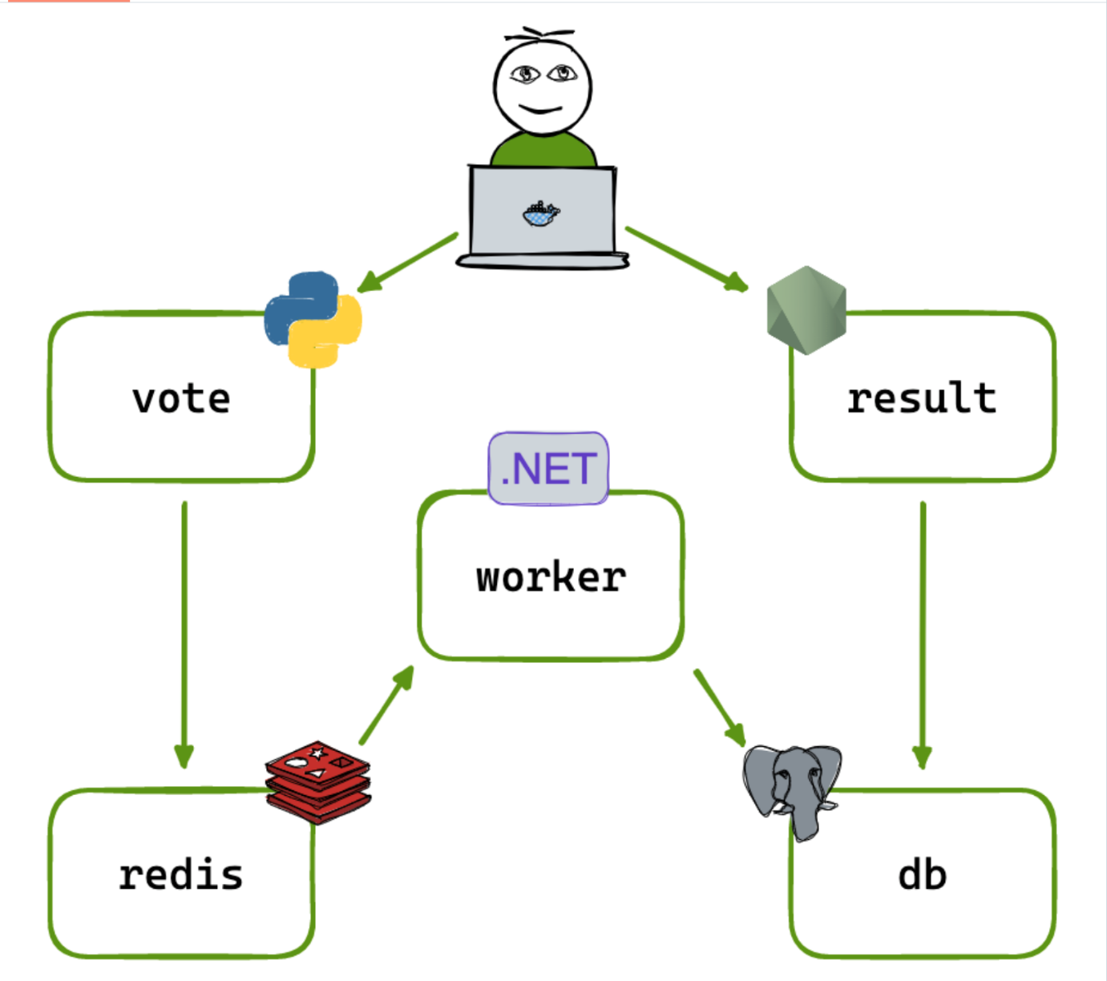](https://private-user-images.githubusercontent.com/43399466/303641413-ad4dbb37-82f4-4663-9bcb-e919f0bb101b.png?jwt=eyJhbGciOiJIUzI1NiIsInR5cCI6IkpXVCJ9..oltjnwfclhmwXI0Z5gz8QZ692Htdow3DpIfJ2tpkwN8)

**Day 15: Azure DevOps - CD Setup - (PROJECT 3)**

* Implementing Continuous Deployment (CD)
* Using AKS for CD
* Creating AKS cluster on Azure
* Configuring Virtual Machine Scale Sets as Node pools in AKS
* Hands on sessions on AKS
* End to End CI/CD Demonstration

**Day 16: Azure Kubernetes Services(AKS Deep Dive)**

* AKS Deep Dive
* Understanding AKS vs Self managed Kubernetes clusters

**Day 17: Deploying a Three Tier architecture E-commerce (8 Services, 2 Databases) on AKS - (PROJECT 4)**

* Understand what is three tier architecuture
* How different services connect to each other in three tier architecture
* How to create Dockerfiles for each service ?
* How to create Deployment, Service and Ingress
* How does Ingress controller work ?
* Expose the three tier application to end users.

[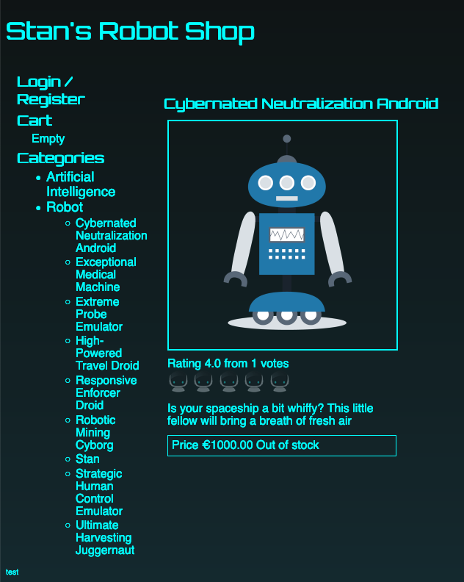](https://private-user-images.githubusercontent.com/43399466/305347599-0623a010-d8f1-4632-abce-d06f5755b1fa.png?jwt=eyJhbGciOiJIUzI1NiIsInR5cCI6IkpXVCJ9..qiYLQeQys8LaIEkqbdnwK2cXLr_cC_MVJkCsIn04yyw)

**Day 18: Azure DevOps Interview Questions**

* Beginner level Azure DevOps Interview Q&A
* Advanced level Azure DevOps Interview Q&A

**Day 19: Azure Cloud Watch(Monitor) and Monitoring Services**

* Monitoring Overview
* Setting Up Monitoring in Azure

**Day 20: Azure Key Vault**

* Secrets Management with Key Vault
* Security Best Practices
* **PROJECT** - Integrate Azure Keyvault with Secrets Store CSI Driver

**Day 21: Azure Serverless**

* Understanding Azure Serverless Services
* Going Serverless with Azure

**Day 22: Event Driven Serverless - (PROJECT 5)**

* Create Azure Functions that are triggered by Azure Blob creation

**Day 23: Manage Azure Resources using Terraform - (PROJECT 7)**

* How to connect Azure with Terraform
* How to create resources on Azure with Terraform
* State file management of Terraform in Azure
* Best Practices

**Day 24: Azure DevOps Resume preparation for Freshers and Experienced**

* How to create an impressive resume on Azure DevOps
* How to add projects to the Resume

**Day 25: Azure Interview Preparion**

* Review of Key Concepts
* Interviews Questions and Practice Sessions